Project Design Phase-II
Technology Stack (Architecture & Stack)

Date | 30 August 2026
Team ID
Project Name | An employee requests installation of licensed software through the Service Catalog
Maximum Marks | 4 Marks

Technical Architecture:
The Deliverable shall include the architectural diagram as below and the information as per the table1 & table 2
Example: An employee requests installation of licensed software through the Service Catalog
Reference: https://developer.ibm.com/patterns/ai-powered-backend-system-for-order-processing-during-pandemics/
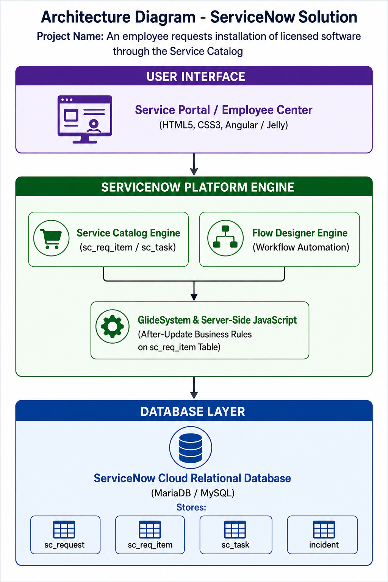

Table-1 : Components & Technologies:

S.No | Component | Description | Technology
1 | User Interface | Self-Service Portal for submitting software requests and tracking status. | ServiceNow Service Portal (HTML5, CSS3, Angular / Jelly Framework)
2 | Application Logic-1 | Automated workflow engine generating catalog tasks upon request submission. | ServiceNow Flow Designer
3 | Application Logic-2 | Server-side business logic detecting On Hold states and auto-logging incidents. | JavaScript (GlideRecord & ServiceNow Server-Side API)
4 | Application Logic-3 | Update Set packaging engine managing project configuration state. | System Update Sets (sys_remote_update_set)
5 | Database | Platform relational database storing form records, workflow instances, and tasks. | ServiceNow Database Schema (MariaDB / MySQL backing sc_req_item, sc_task, incident)
6 | Cloud Database | Cloud-hosted enterprise data layer managed by ServiceNow SaaS infrastructure. | Enterprise ServiceNow Multi-Instance Architecture
7 | File Storage | Storage for exported project configuration files and update logs. | ServiceNow Attachment Repository & XML File Exporter
8 | External API-1 | Integration interface for system-to-system notifications or status queries. | ServiceNow REST / SOAP APIs
9 | External API-2 | Automated email engine for user request status notifications. | ServiceNow Notification Engine (SMTP / Email Outbound)
10 | Machine Learning Model | Optional predictive intelligence module for auto-categorizing software requests. | ServiceNow Predictive Intelligence (Virtual Agent / ML Engine)
11 | Infrastructure (Server / Cloud) | Scalable cloud deployment environment hosting the ServiceNow Developer Instance. | Cloud Configuration: ServiceNow SaaS Enterprise Cloud Infrastructure

Table-2: Application Characteristics:

S.No | Characteristics | Description | Technology
1 | Open-Source Frameworks | Front-end portal UI components and lightweight client scripts. | AngularJS, Bootstrap, HTML5, JavaScript ES6
2 | Security Implementations | Access control rules (ACLs) ensuring only authorized fulfillers manage tasks and incidents. | Role-Based Access Control (RBAC), HTTPS/TLS Encryption, OAuth 2.0
3 | Scalable Architecture | Enterprise 3-tier architecture separating Portal UI, Workflow Business Logic, and Database layers. | ServiceNow SaaS Platform (3-Tier Cloud Architecture)
4 | Availability | High-availability cloud infrastructure with automated redundant failover instances. | Advanced High Availability (AHA) Multi-Region Deployment
5 | Performance | Optimized server-side GlideRecord queries ensuring sub-second business rule execution. | Server-Side Scripting, In-Memory Caching, CDN-backed static assets

References:
https://c4model.com/
https://developer.ibm.com/patterns/online-order-processing-system-during-pandemic/
https://www.ibm.com/cloud/architecture
https://aws.amazon.com/architecture
https://medium.com/the-internal-startup/how-to-draw-useful-technical-architecture-diagrams-2d20c9fda90d

